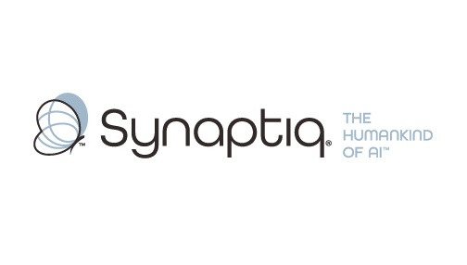
______________________________________________________________________
 | Stephen Sklarew  CEO & Co-Founder, Synaptiq  AI Strategy & Workforce Transformation | "The Humankind of AI"

Overview
Stephen Sklarew is a seasoned executive with over 30 years of experience in AI strategy, data architecture, and enterprise technology transformation. As CEO of Synaptiq, he specializes in advancing organizations through complex phases of AI maturity, particularly in document processing, RAG systems, and unstructured data challenges. His expertise spans Analytics Lifecycle Management and AI implementation at scale, with proven experience helping technical teams navigate nuanced architectural decisions around multi-format document ecosystems. Stephen's approach aligns with Synaptiq's "Humankind of AI" philosophy, emphasizing performance-driven outcomes and business value creation through the proprietary AIQ® methodology that integrates advanced analytics strategy with practical implementation frameworks.
Background & Expertise
Stephen Sklarew is a seasoned business and technology executive with over 30 years of experience driving AI innovation and data transformation across enterprise organizations. His deep expertise in Analytics Lifecycle Management, advanced document processing systems, and enterprise AI architecture makes him uniquely positioned to guide organizations through complex phases of AI maturity. As CEO and cofounder of Synaptiq, an AI strategy and solutions firm founded in 2015, Stephen focuses on helping technical teams navigate sophisticated challenges around RAG systems, multi-format document processing, and scalable AI implementation.
Prior to his current role, Stephen held senior positions at companies like Sage Software, CEB (now Gartner), and Ernst & Young LLP, where he led technology initiatives that transformed how organizations process, structure, and extract value from unstructured content. His experience spans venture-backed startups including CircleBack (now SalesIntel), where he pioneered SaaS products utilizing big data and machine learning for document intelligence and information retrieval.
Stephen has guided technology transformations across diverse industry sectors including manufacturing, healthcare, technology, and enterprise services, with particular strength in helping organizations balance generalized versus highly specific processing approaches. Under his leadership, Synaptiq developed its proprietary AIQ® methodology, a comprehensive framework that addresses the nuanced architectural decisions organizations face when scaling AI capabilities from initial implementations to enterprise-wide deployment.
Stephen's approach emphasizes performance measurement and business value alignment - critical factors when advancing beyond foundational AI work into sophisticated document ecosystems. His philosophy of building solutions that catalyze human ingenuity, exemplified by Synaptiq's "Humankind of AI" tagline, resonates with innovation-driven cultures focused on practical outcomes and measurable impact. Stephen is a thought leader in enterprise AI architecture and frequently shares insights on navigating complex AI maturity phases through speaking engagements and industry publications. He holds a BS in Biology from Virginia Tech.
Relevant Experience
- Multi-Format Document Processing Architecture: Led enterprise implementations of RAG systems handling diverse document types (PDFs, Excel, PowerPoint, Word) with optimized retrieval quality and scalable processing pipelines. Specialized in balancing generalized versus highly specific processing approaches for complex document ecosystems.
- AI Maturity Phase Transitions: Guided organizations through sophisticated "second phase" AI implementations, helping technical teams navigate nuanced architectural decisions and performance optimization challenges. Expert in scaling from foundational AI work to enterprise-wide deployment.
- Analytics Lifecycle Management at Scale: Developed comprehensive frameworks for managing complex data processing workflows across manufacturing and technology environments. Focus on extracting meaningful insights from unstructured content while maintaining performance standards.
- Golden Dataset Development & Evaluation: Established methodologies for structuring evaluation datasets and measuring AI system performance against business value metrics. Experience creating benchmarks for document intelligence and retrieval quality assessment.
- Enterprise AI Strategy & Implementation: Led strategic AI initiatives across technology, manufacturing, and enterprise services sectors, with focus on aligning technical capabilities with business outcomes. Proven track record in workforce transformation and organizational AI adoption.
- Unstructured Data Intelligence Systems: Architected solutions for ingesting, structuring, and retrieving information from complex document sets in enterprise environments. Experience with SaaS products utilizing machine learning for document processing and business intelligence.

